Name__________________________________________________________________________Hour__________
The Science of Swing Task Sheet
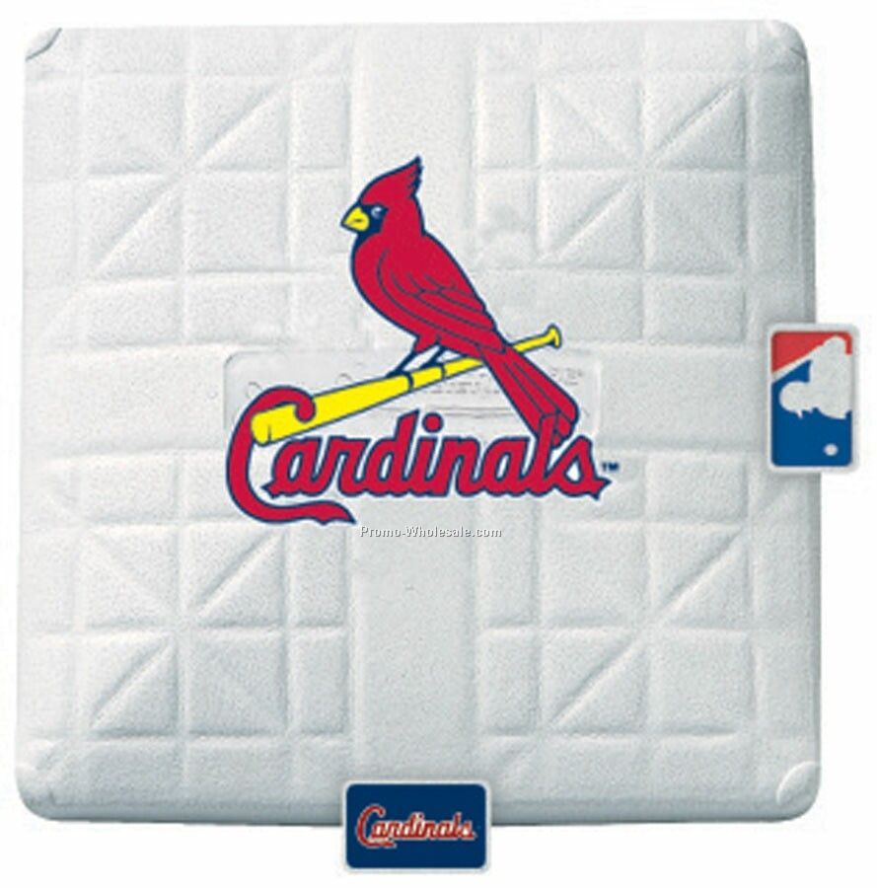1st base: Summarize the three correct steps to swing a bat in your own words. Please use at least two complete sentences.
______________________________________________________________________________________________________________________________________________________________________________________________________________________________________________

2nd base:
>About how much time does it take a fastball to go from mound to the plate?
__________________________________________________________
>Where are you most likely to hit a homerun and why?
__________________________________________________________________________________________________________________________________
3rd base: Fastest Reaction Time
Name | Time (seconds)

